Bluetooth
- Last Updated : 14 Aug, 2020
It is a Wireless Personal Area Network (WPAN) technology and is used for exchanging data over smaller distances. This technology was invented by Ericson in 1994. It operates in the unlicensed, industrial, scientific and medical (ISM) band at 2.4 GHz to 2.485 GHz. Maximum devices that can be connected at the same time are 7. Bluetooth ranges upto 10 meters. It provides data rates upto 1 Mbps or 3 Mbps depending upon the version. The spreading technique which it uses is FHSS (Frequency hopping spread spectrum). Frequency-hopping spread spectrum (FHSS) is a method of transmitting radio signals by rapidly changing the carrier frequency among many frequencies occupying a large spectral band. The changes are controlled by a code known to both transmitter and receiver.A bluetooth network is called piconet and a collection of interconnected piconets is called scatternet.
Bluetooth Architecture:
The architecture of bluetooth defines two types of networks:
1. Piconet
2. Scatternet
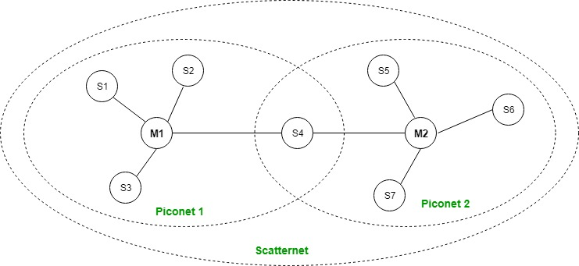
Piconet:

Piconet is a type of bluetooth network that contains one primary node called master node and seven active secondary nodes called slave nodes. Thus, we can say that there are total of 8 active nodes which are present at a distance of 10 metres. The communication between the primary and secondary node can be one-to-one or one-to-many. Possible communication is only between the master and slave; Slave-slave communication is not possible. It also have 255 parked nodes, these are secondary nodes and cannot take participation in communication unless it get converted to the active state.
Scatternet:
It is formed by using various piconets. A slave that is present in one piconet can be act as master or we can say primary in other piconet. This kind of node can receive message from master in one piconet and deliver the message to its slave into the other piconet where it is acting as a slave. This type of node is refer as bridge node. A station cannot be master in two piconets.
Bluetooth protocol stack:

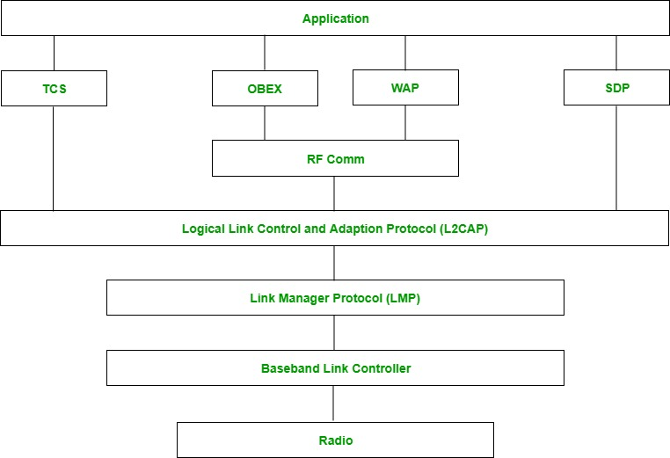

- Radio (RF) layer:
It performs modulation/demodulation of the data into RF signals. It defines the physical characteristics of bluetooth transceiver. It defines two types of physical link: connection-less and connection-oriented.
- Baseband Link layer:
It performs the connection establishment within a piconet.
- Link Manager protocol layer:
It performs the management of the already established links. It also includes authentication and encryption processes.
- Logical Link Control and Adaption protocol layer:
It is also known as the heart of the bluetooth protocol stack. It allows the communication between upper and lower layers of the bluetooth protocol stack. It packages the data packets received from upper layers into the form expected by lower layers. It also performs the segmentation and multiplexing.
- SDP layer:
It is short for Service Discovery Protocol. It allows to discover the services available on another bluetooth enabled device.
- RF comm layer:
It is short for Radio Frontend Component. It provides serial interface with WAP and OBEX.
- OBEX:
It is short for Object Exchange. It is a communication protocol to exchange objects between 2 devices.
- WAP:
It is short for Wireless Access Protocol. It is used for internet access.
- TCS:
It is short for Telephony Control Protocol. It provides telephony service.
- Application layer:
It enables the user to interact with the application.
Advantages:
- Low cost.
- Easy to use.
- It can also penetrate through walls.
- It creates an adhoc connection immediately without any wires.
- It is used for voice and data transfer.
Disadvantages:
- It can be hacked and hence, less secure.
- It has slow data transfer rate: 3 Mbps.
- It has small range: 10 meters.

IEEE 802.11 Architecture
The IEEE 802.11 standard, commonly known as Wi-Fi, outlines the architecture and defines the MAC and physical layer specifications for wireless LANs (WLANs). Wi-Fi uses high-frequency radio waves instead of cables for connecting the devices in LAN. Given the mobility of WLAN nodes, they can move unrestricted within the network coverage zone. The 802.11 structure is designed to accommodate mobile stations that participate actively in network decisions. Furthermore, it can seamlessly integrate with 2G, 3G, and 4G networks.
The Wi-Fi standard represents a set of wireless LAN standards developed by the Working Group of IEEE LAN/MAN standards committee (IEEE 802). The term 802.11x is also used to denote the set of standards. Various specifications and amendments include 802.11a, 802.11b, 802.11e, 802.11g, 802.11n etc.

Important Terminologies of IEEE 802.11 Architecture
Station: Stations (STA) comprise all devices and equipment that are connected to the wireless LAN. It can be of two types:
- Wireless Access Point (WAP): WAPs or simply access points (AP) are wireless routers that bridge connections for base stations.
- Client: Examples include computers, laptops, printers, and smartphones.
Access Point: It is a device that can be classified as a station because of its functionalities and acts as a connection between wireless medium and distributed systems.
Distribution System: A system used to interconnect a set of BSSs and integrated LANs to create an ESS.
Frame: It is a MAC protocol data unit.
SSID (Service Set Identifier): It’s the network name for a particular WLAN. All-access points and devices on a specific WLAN must use the same SSID to communicate.
SDU: It is a data unit that acts as an input to each layer. These can be fragmented or aggregated to form a PDU.
PDU: It is a data unit projected as an output to communicate with the corresponding layer at the other end. They contain a header specific to the layer.
Network Interface Controller: It is also known as network interface card. It is a hardware component that connects devices to the network.
Portal: Serves as a gateway to other networks

IEEE 802.11 Architecture and Services
In the year 1990, IEEE 802.11 Committee formed a new working group, the IEEE 802.11 standard which defines protocols for Wireless Local Area Networks (WLANs). Just like how Ethernet provides services for wired media, IEEE 802.11 architecture is designed to provide features for wireless networks.
An AP supports both wired and wireless connections. The 802.11 standard calls the upstream wired network the distribution system (DS). The AP bridges the wireless and wired L2 Ethernet frames, allowing traffic to flow from the wired to the wireless network and vice versa. Each wireless network has a unique SSID.
The 802.11 architecture provides some basic services for WLANs whose implementation is supported by MAC layer:

Basic Service Set
The Basic Service Set configuration consists of a group of stations and relies on an Access Point (AP), which serves as a logical hub. Stations from different BSSs interact through the AP, which functions as a bridge, linking multiple WLAN cells or channels.

Operating Modes
Depending upon the mode of operation, BSS can be categorized into the following types:
- Infrastructure BSS: Communication between stations takes place through access points. The AP and its associated wireless clients define the coverage area and form the BSS.
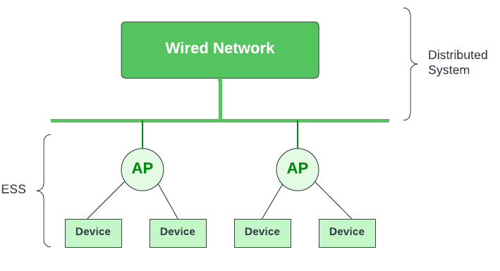

- Independent BSS – Supports mutual communication between wireless clients. An ad-hoc network is spontaneously created and does not support access to wired networks.

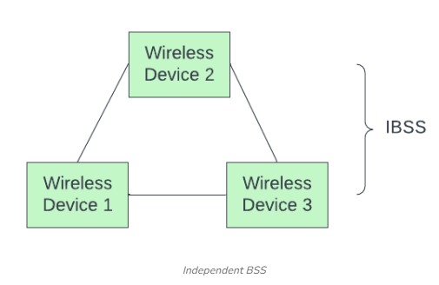

Independent Basic Service Set
In the IBSS configuration, also referred to as independent configuration or ad-hoc network, no single node is required to act as a server. The stations communicate directly with one another in a peer-to-peer basis. Generally, IBSS covers a limited area instead of a large network. Typically covering a specific area, IBSS is used for specific, short-term purposes with a limited number of nodes.

Extended Service Set
ESS connects multiple BSSs and consists of several BSS cells, which can be interlinked through wired or wireless backbones known as a distributed system. Multiple cells use the same channel to boost aggregate throughput to network. The equipment outside of the ESS, the ESS and all of its mobile stations comprise a single MAC layer network where all stations are virtually stationary. Thus, all stations within the ESS appear stationary from an outsider’s perspective.
Other components include:
- Distribution System (DS): Links APs within the ESS.
- Portal: Serves as a gateway to other networks.
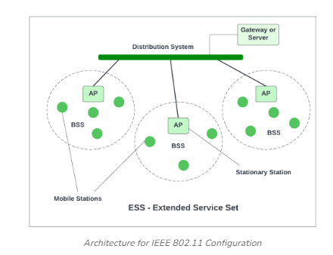
- Roaming: In an environment with multiple access points (like a large office building or campus), a device can move from the range of one AP to another and still maintain its connection. This is possible due to the underlying architecture of the IEEE 802.11 standard which allows for roaming between APs.
- Authentication and Association: Before a station can send or receive data frames on a WLAN, it needs to establish its identity with an AP. This process is called authentication. After authentication, the station then establishes a data link-layer connection with the AP through a process called association.

Frame Format of IEEE 802.11
IEEE 802.11 MAC layer data frame consists of 9 fields:
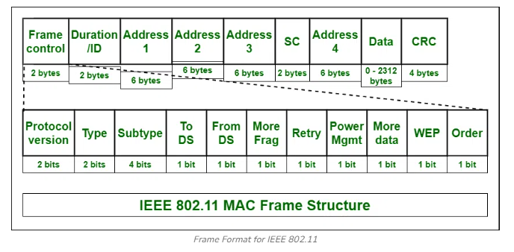

Frame Control
It is 2 bytes long and defines type of frame and control information. The types of fields present in FC are:
- Version: Indicates the current protocol version.
- Type: Determines the function of frame i.e. management(00), control(01) or data(10).
- Subtype: Indicates subtype of frame like 0000 for association request, 1000 for beacon.
- To DS: When set indicates that the destination frame is for DS(distribution system).
- From DS: When set indicates frame coming from DS.
- More frag (More fragments): When set to 1 means frame is followed by other fragments.
- Retry: If the current frame is a re-transmission of an earlier frame, this bit is set to 1.
- Power Mgmt (Power Management): It indicates the mode of a station after successful transmission of a frame. Set to ‘1’ field indicates that the station goes into power-save mode. If the field is set to 0, the station stays active.
- More data: It is used to indicate to the receiver that a sender has more data to send than the current frame.
- WEP: It indicates that the standard security mechanism of 802.11 is applied.
- Order: If this bit is set to 1 the received frames must be processed in strict order.

Duration / ID
It contains the value indicating the period of time in which the medium is occupied (in µs).

Address 1 to 4
These fields contain standard IEEE 802 MAC addresses (48 bit each). The meaning of each address is defined by DS bits in the frame control field.

SC (Sequence Control)
It consists of 2 sub-fields i.e. sequence number (12 bits) and fragment number (4 bits). Sequence number is used to filter duplicate frames.

Data
It is a variable length field which contains information specific to individual frames which is transferred transparently from a sender to the receiver.

CRC (Cyclic Redundancy Check)
It contains 32 bit CRC error detection sequence to ensure error free frame.

Advantages and Disadvantages of IEEE 802.11 Architecture
There are some list of Advantages and Disadvantages of IEEE 802.11 Architecture are given below :

Advantages of IEEE 802.11 Architecture
- Fault Tolerance: The centralized architecture minimizes the bottlenecks and introduces resilience in the WLAN equipment.
- Flexible Architecture: Supports both temporary smaller networks and larger, more permanent ones.
- Prolonged Battery Life: Efficient power-saving protocols extend mobile device battery life without compromising network connections.

Disadvantages of IEEE 802.11 Architecture
- Noisy Channels: Due to reliance on radio waves, signals may experience interference from nearby devices.
- Greater Bandwidth and Complexity: Due to necessary data encryption and susceptibility to errors, WLANs need more bandwidth than their wired counterparts.
- Speed: Generally, WLANs offer slower speeds compared to wired LANs.

Applications of IEEE 802.11 Architecture
- Home Networking: Connecting devices, laptops, smart TVs, speakers, gaming consoles etc.
- Wi-Fi Hotspots: Free or paid internet access to visitors in coffee shops, hotels, airports, malls and restaurants.
- Connectivity in Campus: Provide internet access in university, colleges, schools or corporate campuses.

